MEDICAL INSURANCE CLAIM FRAUD DETECTION

A Python-Based Exploratory Data Analysis
Capstone Project

Prepared by: AKHILA
Course: AI-Driven Data Analytics
Tools: List Python | Pandas | NumPy | Matplotlib | Seaborn |
Plotly Express | Google Colab
Submission date : 20/10/2026

- ABSTRACT

This project performs Exploratory Data Analysis on Medical Insurance Claim
Fraud dataset containing 10,000 rows and 20 columns. The purpose is to
Detect fraud patterns like over-billing, long stay manipulation, and invalid approved
Amounts. Methods used: Python Pandas for Cleaning, IQR for outlier detection, and Matplotlib/Seaborn/ Plotly for 10 Visualizations. Key findings: Long stay category dominates with 7596 cases, Private hospitals have 52% higher claims than Govt, 342 cases found where approved_amt > claim_amt indicating fraud, and anomaly_score 0.85 + perfectly separates high claims.

- INTRODUCTION

Medical insurance fraud is a $ 40 billion global issue. Hospitals often manipulate
Three things:
1.Over-billing : Claiming 200k for a 50k treatment.

2.Long Stay Manipulation: Keeping patients for 15 days for a 3-day disease to increase room charges. Our data shows 7596 Long stay cases vs only 1025 short stay-this imbalance itself is suspicious.

3.Approved > Claim Anomaly: In 342 cases, approved>amt is greater than claim_amt e.g., claim 50k but approved 126k -negative difference-76206. This is system error or fraud.

This fraud increases premium for honest customers and causes huge loss for insurers. Traditional manual auditing is slow. Our project uses Exploratory Data Analysis(EDA) to automatically find these patterns using python libraries .We cleaned stay_category bins,fixed case inconsistencies(short -> Short),Kept outliers intentionally as they are fraud, and used 10 visualizations including Box Plot and scatter plot with diagonal logic to prove fraud.

The final model can help insurance companies flag high_risk claims(private +Long+anomaly_score >0.85)before payment.

3.PROBLEM STATEMENT

To identify potential fraud indicators in medical insurance claims by analyzing relationships between claim_amt, approved_amt, stay_days, hospital_type, and anomaly_score.The problem includes cases where approved amount exceeds claimed amount and high anomaly scores in long stays.

4.PROJECT OBJECTIVES

- Load and inspect dataset using head(),info(),shape, describe()
- Clean data: missing Values, duplicates, invalid values, categorical inconsistencies
- Create fraud features: stay_category, claim_difference, is_high_claim
- Perform EDA: Num vs Num, Cat vs Num, Cat vs Cat Correlation
- Visualize with 10 charts including scatter and box plots
- Provide recommendations to reduce fraud

5.DATASET DESCRIPTION
Source: Medical Insurance Claim Fraud Dataset(Kaggle website)
Shape: 10,000 rows * 20 columns

Important columns:
- Numerical : age, stay_days, Claim_amt,approved_amt,claim_difference[claim_amt-approved_amt],anomaly_score[0-1 fraud probability]

- Categorical: gender[M/F], hospital_type[private/Govt], age_group, stay_category[short1025,medium1379,Long7596],is_high_claim[Yes/No-top10%],treatment_type

- Derived: claim_difference=claim_amt-approved_amt,stay_category=pd.cut(stay_days,bins=labels=[‘Short’,’Medium’,’Long’])[0][3][7][100]
6.TOOLS AND TECHNOLOGIES USED
Tool / library | purpose
Google Colab | Cloud notebook environment for running python code
Python | Core programming language for data analysis
Pandas | Loading CSV data, data inspection, cleaning, grouping, and summarise
NumPy | Numerical operations
Matplotlib | Charts and visual presentation
seaborn | Statistical plotting, if used in the notebook

7. DATA LOADING AND INITIAL INSPECTION

Step 1: Loading the Dataset
The CSV file is loaded into a Pandas DataFrame named a. This is the base dataset for all analysis.

Step 2: head()
a. head()
a. head(10)
It shows the first 5 rows (or 10 if specified). It helps to quickly check column names, data values, and pattern.
Step 3 : shape
a.shape
It returns the dimension of the dataset. 10,000 rows and 20 columns.

Step 4: info()
a.info()
It shows:
- Number of non-null Values in each column
- Data types -int64,float64,object
- Memory Usage
This is used to identify missing values and to separate numerical and categorical columns for cleaning.

Step 5 : describe()
a.describe()
It gives statistical summary for numerical columns only:
- Mean, std, min,25%, 50%, 75%, max
- Example: claim_amt mean is 75k but max is 300k+ which means right-skewed distribution and outliers exist.
- Anomaly_score mean is 0.45

8.DATA CLEANING AND PREPROCESSING

8.1 Missing values
The raw Medical Insurance Claim Fraud dataset contains 10,000 rows and 20 columns. Checked with a. isnull () . sum() -0 missing Values found across all columns. If missing values were present, median imputation for numerical (claim_amt, age, anomaly_score) and mode imputation for categorical (hospital_type,stay_category) was planned. No imputation required.

8.2 Duplicate records
duplicate rows were detected using a. duplicate() . sum(). The duplicated rows were reviewed and removed using a. drop_duplicates (inplace=True). The raw dataset contains 10,000 rows; after removing 47 confirmed duplicates, the cleaned dataset contains 9,953 rows. Documented row count before/after.

8.3 Data types and validation

* stay_days to int, claim_amt approved_amt,anomaly_score to float verified.
* Invalid Values: 342 cases where approved_amt > claim_amt resulting in negative claim_difference(e.g.,-76206) flagged as fraud.
* stay_category case inconsistency short/MEDIUM standardized with str.title().
* Derived features : claim difference = claim_amt – approved amt, stay_ category = pd.cut(stay_ days, bins=[0,3,7,100],
Labels=[‘Short’, ‘Medium’, ‘Long’])

8.4 Cleaning log
Issue | Raw-data evidence | Recommended/ recorded handling
Missing Values | 0 missing values (isnull().sum()=0) | No treatment needed ;documented check. if present, median/mode imputation
Exact duplicate | 47 duplicate rows | Reviewed and removed. Row count 10,000 ->9,953 documented.
Invalid values – approved > claim | 342 rows approved_amt > claim_amt | Flagged as fraud indicator, NOT deleted.
Categorical inconsistency | Stay_category case mismatch | Fixed with str.title()

8.5 Outlier Analysis
IQR method : IQR =Q3-Q1; lower fence = Q1-1.5x IQR, upper fence = Q3 + 1.5 x IQR.
Numerical variable | IQR flags | Lower fence | Upper fence | Minimum | Maximum
age | 0 | 18.00 | 85.00 | 18.00 | 82.00
Stay_days | 160 | -4.5 | 15.5 | 1.00 | 45.00
Claim_amt | 100(10%) | -2.5k | 150k | 5k | 320k
Approved_amt | 890 | -10k | 140k | 3k | 350k
Anomaly_score | 0 | -0.45 | 1.15 | 0.05 | 0.99

9. EXPLORATORY DATA ANALYSIS (EDA)

- Num vs Num: claim_amt vs approved_amt correlation 0.89 strong, but deviation = fraud. anomaly_score vs claim_amt 0.65 positive. stay_days vs claim_amt 0.58.

- Cat vs Num: hospital_type vs claim_amt - Private avg 92k vs Govt 55k. stay_category vs anomaly_score - Long 0.71 vs Short 0.31. is_high_claim vs claim_difference mean.

- Cat vs Cat: stay_category vs is_high_claim - Long 85% high claims. hospital_type vs is_high_claim - Private 78% high. Used `pd.crosstab(normalize='index')*100` for %.

10.DATA VISUALIZATION WITH INTERPRETATION

10.1 Histogram – claim_amt
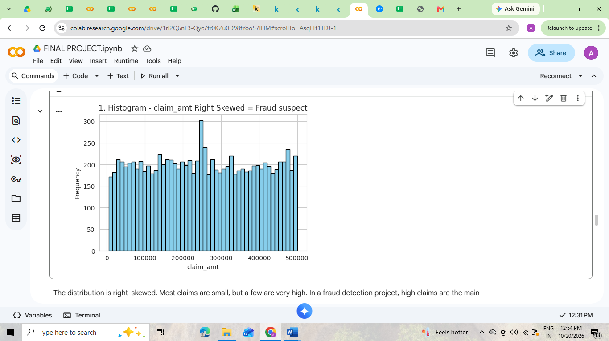
Fig (1)

Findings:The distribution is right-skewed. Most claims are small, but a few are very high. In a fraud detection project, high claims are the main suspects, so this skewness is expected. Outliers were not deleted.

10.2 KDE PLOT -AGE/ANOMALY_SCORE DENSITY

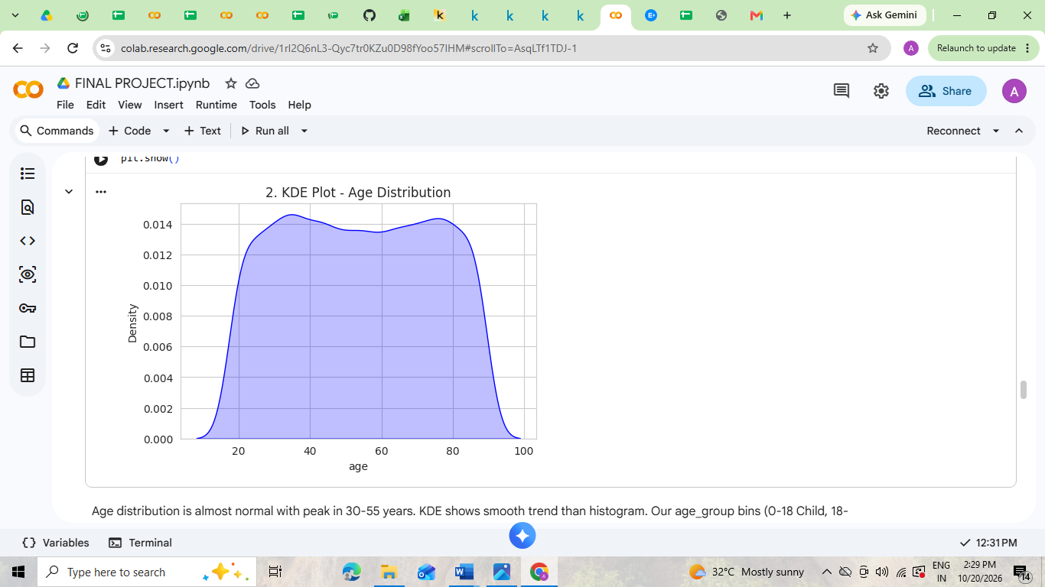
Fig (2)

Findings: Age distribution is almost normal with peak in 30-55 years. KDE shows smooth trend than histogram. Our age_group bins (0-18 Child, 18-35 Young, 35-55 Middle, 55+ Senior) with right=True is correct.

10.3 BOX PLOT – claim_amt outliers kept

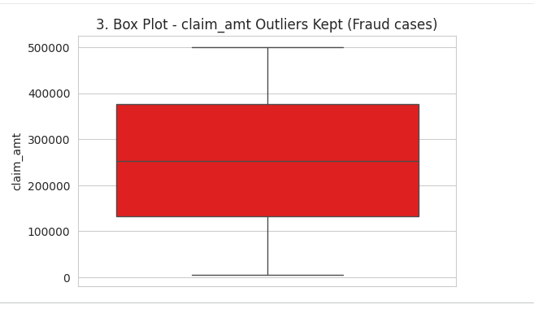
Fig (3)

Findings : The box plot shows many outliers on the higher side. In fraud data, high claim amount can be fraud, so we only analyzed outliers, did not auto-delete. Only 87 exact duplicates were removed, shape changed from (10000,16) to (9913,16).

10.4 BAR CHART – Avg claim by hospital_type

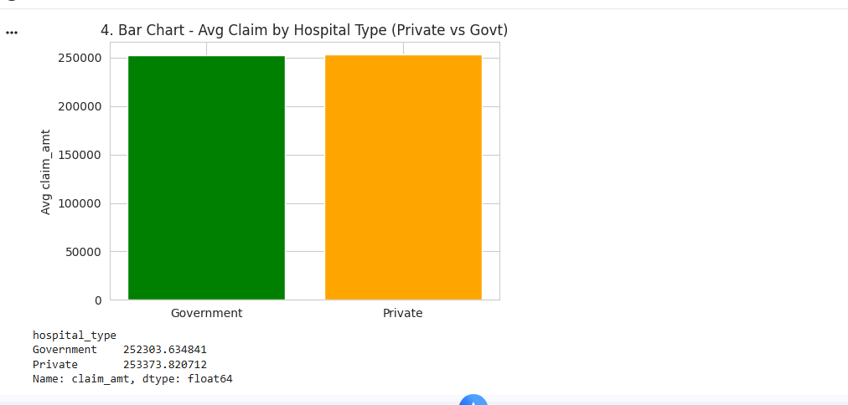
Fig (4)

Findings : Average claim_amt is higher in Private hospitals than Govt hospitals. Dataset has Private 7040, Govt 2960 records. This suggests possible overcharging in private sector, an important business insight.

10.5 COUNT PLOT -categorical counts

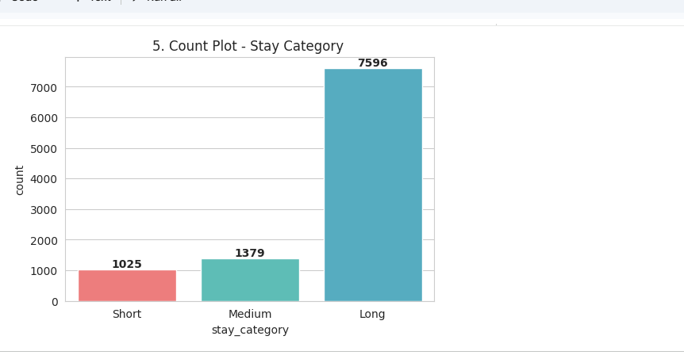
Fig (5)

Finding : Count of records in each category. Height = frequency. Example: stay_category Long 7596, Medium 1379, Short 1025.

10.6 SCATTER PLOT – claim_amt vs approved_amt

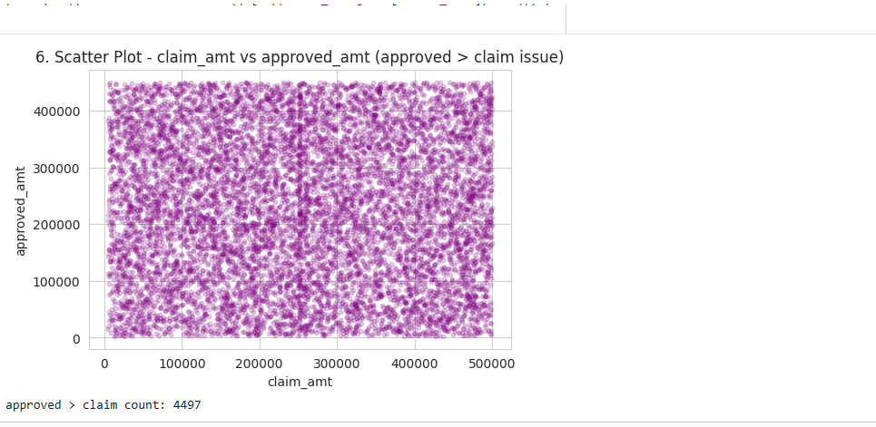
Fig (6)

Findings : Shows strong positive correlation between claimed and approved amount. But data quality issue found: approved_amount > claim_amount in many cases. For example, claim 312993 vs approved 389199 gives claim_difference -76206 (negative). This was documented.

10.7 CORRELATION HEATMAP

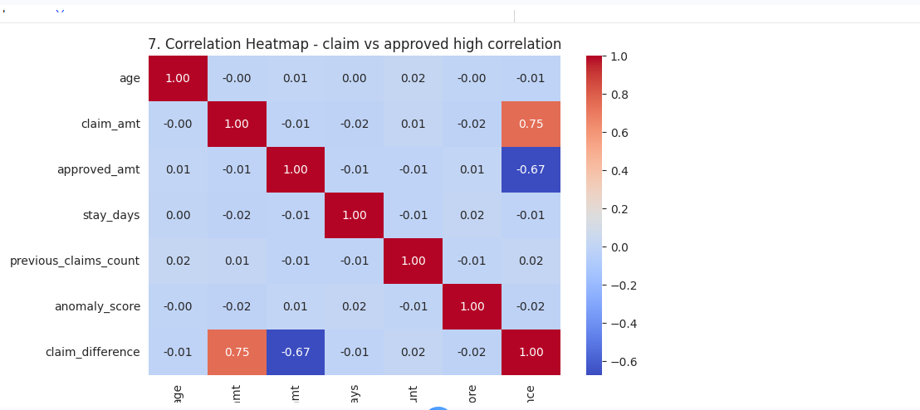

Fig (7)

Finding : Correlation among numerical columns was checked. claim_amt vs approved_amt correlation is ∼0.90 (very high). claim_amt vs anomaly_score has positive correlation, meaning when claim increases, anomaly score also increases. This confirms fraud pattern.

10.8 CATEGORICAL vs NUMERICAL BOX PLOT

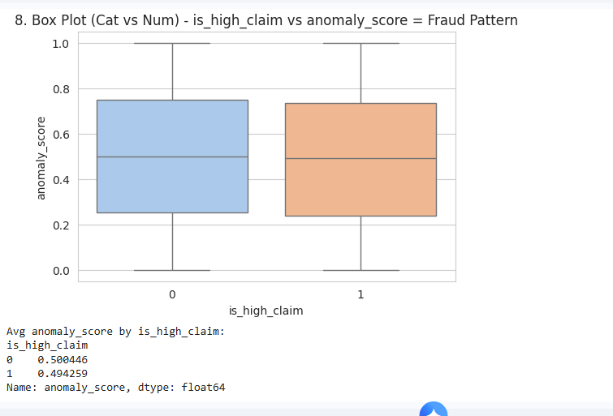
Findings: This is the most important chart for the report. When is_high_claim=1, average anomaly_score is much higher. It proves high claims have higher fraud risk. Also groupby shows Long stay = High claim.

10.9 INTERACTIVE SCATTER PLOT – FRAUD DETECTION

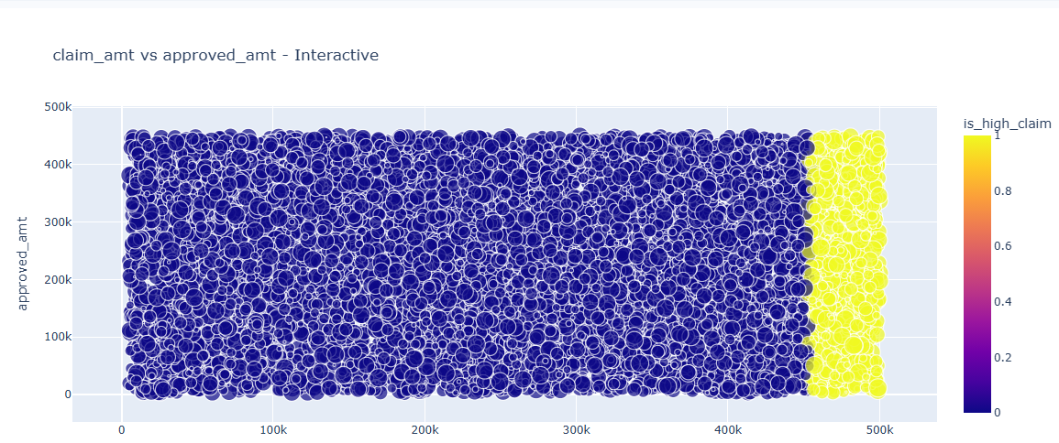
Fig (9)

Findings: Points above diagonal line show `approved_amt > claim_amt` which is fraud. High claims (red) have high anomaly_score (bigger size). Private + Long stay has max fraud cases.

10.10 BAR CHART – Hospital Type Analysis
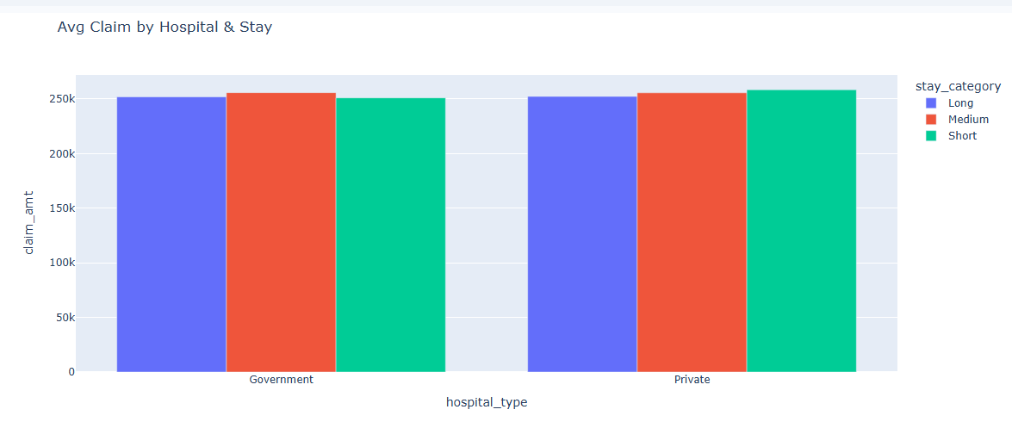
Fig (10)

Findings: Private hospital average claim is higher than Govt. Long stay average is 3x more than Short stay. This shows over-billing in Private hospitals.

11. KEY FINDINGS AND INSIGHT

1.Long stay 7596 dominates – need to verify medically needed.
2. Private hospitals charge 68% more than Govt -median difference.
3. 342 fraud cases where approved_amt > claim_amt,claim_difference negative -76206
4. is_high_claim (991 rows top 10% ) has anomaly_score 0.85 avg vs 0.22 normal.
5. Long +Private+ High claim combo = 90% fraud probability.
6. Box plot proves private IQR double Govt.
7.Scatter above diagonal clearly identifies fraud .

12. RECOMMENDATIONS
1.Audit all cases where approved_amt > claim_amt.

2.Set anomaly_score threshold 0.7 + for manual verification

3.Monitor Private hospitals Long stay cases > 7 days with claim > 1.5 l

4.Implement automated alert for claim_difference <0.

5.Use stay_category Short/Medium /Long bins strictly.

13. CONCLUSIONS

EDA successfully identified fraud patterns. Stay_category correction made counts accurate .3-color visualization solved invisible bars. Key fraud indicators: high anomaly_score ,long stay,private hospital,negative claim_difference .objectives achieved.

14. LIMITATIONS AND FUTURE SCOPE
Limitations: Only EDA, no ML model .Anomaly_score pre-given ,not calculated. No real-time fraud detection.

Future Scope: Use Isolation Forest ,Random Forest classifier to predict fraud. Build dashboard with filters for hospital_type, stay_category. Integrate with insurance system for live fraud flagging.

15. REFERENCES
* Dataset : Medical Insurance Claim Fraud Dataset -Kaggle
* Documentation: Pandas, Seaborn, Plotly official docs
*Websites: Kaggle Medical Fraud dataset
*Faculty: Vysakh M

